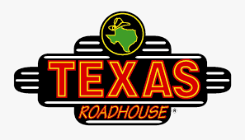
Fall Fundraiser
Rolls and Gift Cards

This fundraiser is just in time for Thanksgiving and the Holiday Season. We will be selling Texas Roadhouse Bread Rolls and $10 Texas Roadhouse Gift Cards for the fall fundraiser.
These are frozen rolls for $10.00 a dozen, plus the popular honey cinnamon butter is included. We also have available $10 Texas Roadhouse Gift Cards with the BCFSC logo printed on them which makes a nice personized gift for your friends and family.

We are asking everyone to participate. Full members are required to sell (10) Dozen Rolls or gift cards, and the buy-out is $25.00.

Orders (and money) are due to BCFSC by Thursday, October 29, 2020.
Rolls are scheduled to be picked up – Monday, November 23, 2020 after 4:00PM
(This date is subject to change)

If you have any questions, you can email trisha@bcfsc.org or ask a board member.

